Directions for Doctors/Providers: These instructions are provided as a courtesy to our TouchMD clients. Please review and feel free to alter the instructions and/or images. Please note, we have only provided example images of the face. You may want to consider including example images of other services/procedures/surgeries available at your practice.

Directions for Patients: Utilizing the HIPAA compliant myTouchMD app, please take and upload one (1) photo of each angle of the area of your concern (i.e., face, body, breast, etc…).

- You may take the photos yourself if desired. If you do so, please utilize a mirror for body and breast consults. For the face, please utilize the “selfie” mode.

- You may have someone else take the photo if desired.

- If at all possible, please have a clean background for your photo. For example, take the photo in front of a blank wall that is free of distractions. We also recommend taking each angle of the photo at the same distance and level, and using good lighting.

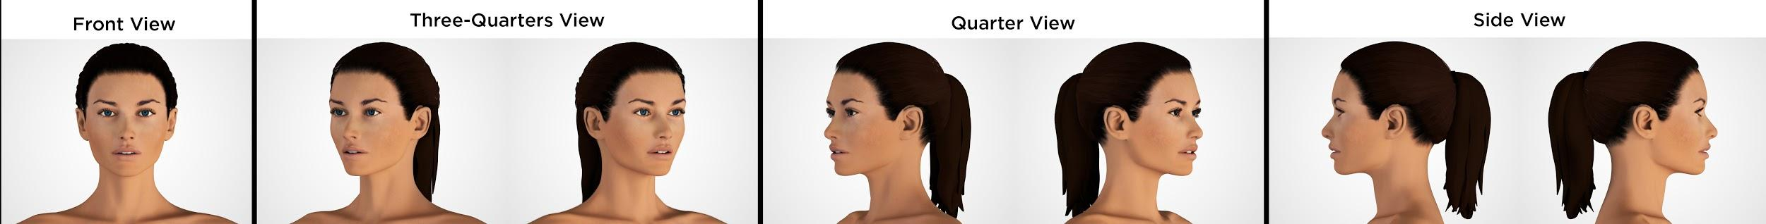

How do I upload an image into my myTouchMD account?

Please review these instructions: https://www.touchmd.com/patientresources

